Intelligent Robotics Project Proposal: Malayah Powlette

Gesture Command: A Camera-Based Gesture Recognition system for British and American sign language
Same issue:
https://forum.coppeliarobotics.com/viewtopic.php?t=10729

RESOURCE:
Rendering signs
https://www.youtube.com/watch?v=MJCSjXepaAM

Put in super markets in front to take though to products?
put In libraries took take those to books/genres ?
Words to implement: https://www.signbsl.com/

Make robot follow path
https://www.youtube.com/watch?v=9Epp4C6xHF4

--------gonna have to use what is on Coppelia (bowl and cup)
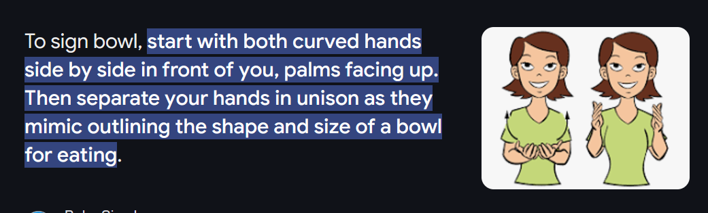
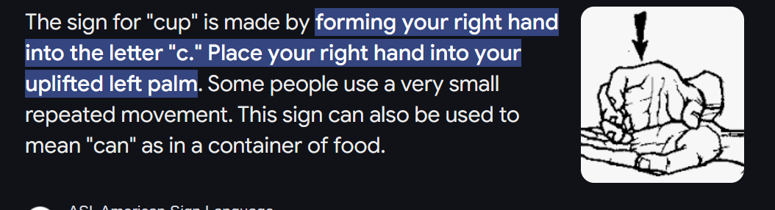
Fruits- https://www.youtube.com/watch?v=Y3Y08jaI1BI
Bread
Butter
Pizza
Horror
Manga
Non-Fiction
Letters

I aim to create a functional robot program that can understand a pre-inputted list of sign language gestures in both American sign language and British sign language. The robot’s program will allow it to input sign language gestures from a human participant and translate what they are saying word by word. Hopefully, if I have the time and skill, I will program it to recognise when a whole sentence has been completed and to translate full sentences once the signer has signally or the robot has interpreted that they have finished.

My reasoning for choosing the project stems from the fact that, during the covid lock downs, I took a strong interest in sign language and grew a great passion to be able to communicate in it. Sadly I did not keep steady in my learning and have been unsuccessfully aiming since to re-learn. I believe learning sign language is so important in our communities for inclusion and that it is simply an amazing and useful skill to have under your belt. Due to this, I would now like to take this project as my opportunity to push myself to re-learn the language and implement my learnings into a program that will understand and translate inputted information from both British and American sign language.

As learning a language far into adult years is a quite difficult and unlikely need for most people, I strongly believe that the creation of programs that can understand and translate sign language are extremely important and it would be incredible to see similar and far more advanced programs implemented in the future. Whether these implementations be In schools, shops or any other useful areas.

There have been many strides to create programs that recognise and translate sign language but sadly it seems this is far from mainstream at the current moment. There are however many technological advancements being made at the moment including amazing technology such as sign language translating glasses; These are a tremendous and I’m sure life changing pieces of technology for communicating between deaf and speaking people however, I believe that what should also be pushed greatly for deaf people and hard of hearing people, that these communities would greatly benefit from, would be easier access to services and resources in the world.
The price point for the translating glasses starts in the mid hundred and places the job of accessibility in the hand of non-deaf every day civilians. Whilst I believe that hearing people should take responsibility in our part to increase inclusion, this is simple not the case for most. This option not only limits the opportunity to those who seek interest in communicating with deaf people and hard of hearing people, but also to the rich who can afford to want to be inclusive without the worry and the issue of having to prioritise other purchases to what they may see as a great opportunity to open up communication to others. This is why I believe that we should create these programs for robots to interpret sign language so that the messages can be processed and transferred to the intended recipient in a more accessible way or people can have quicker and easier assistance simply from the robot itself. I believe these programs could be implemented in situations like tills, help desks for communication with a human working them and drive through services to name a few.

For my implementation of this algorithm, I will attempt to use raspberry pie and a camera to create this program to later program the robot. I will be heavily taking inspiration and following similar steps to those used in the programming of the glasses. This project seems as if it will take a lot of time and studying of the program and I am optimistic that, with the leaps being made in this area, I will be able to make a solid program that can be successfully implemented and tested through a robot. The vocabulary however, will be quite limited due to time and therefore, I will implement simple phrases and common every day words for a smoothly built but still challenging and broadly testable database.

To fully test my program, I will have different subjects show the same gestures to see if the robot is able to correctly recognise them from different individuals. Additionally, I will test and try to make ensure that the robot can best interpret gestures from non-head on angles and make appropriate assumptions as to what is being signed. From my research, it appears most sign language translators implement only either British sign language or American sign language; As to be inclusive, I will provide my program with models of both languages and test both respectively and its interpretation of a mix of both languages.

